**BUILDING CASHIER DASHBOARD PAGE :**

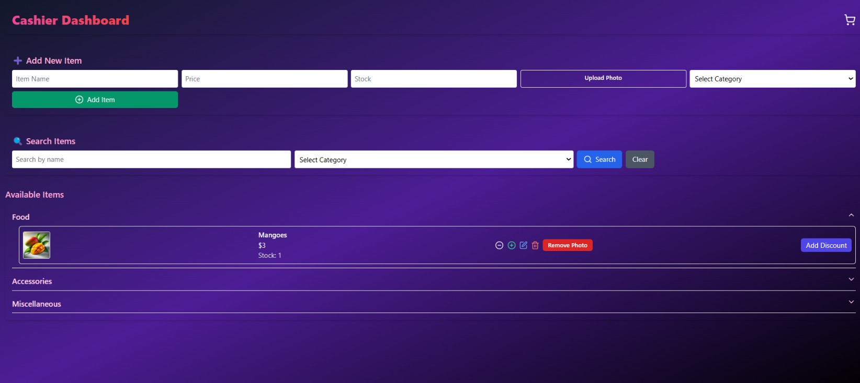

**STEP 1 : Header**

**📄 The Full Code:**

<div className="min-h-screen bg-gradient-to-br from-purple-900 to-purple-500 text-white p-6">

      <h1 className="text-3xl font-bold text-pink-400">Cashier Dashboard</h1>

    </div>

**🔎 Let’s break it by HTML structure + visual effect**

**✅ 1. <div className="..."> — the outer container**

* Think of this like the **main background page**.
* min-h-screen: Makes sure it fills the full height of the screen.
* bg-gradient-to-br from-purple-900 to-purple-800: Adds a nice purple gradient background.
* text-white: Makes the default text color white.
* p-6: Adds space **inside the edges** so the content doesn’t touch the corners.

📦 So this is like:  
**📱 Your full screen purple dashboard container**

**✅ 2. <h1 className="..."> — the heading inside that page**

* text-3xl: Big text (like 24px+)
* font-bold: Makes it thick and strong
* text-pink-400: Makes it that light pink color

🧠 Think of this as:

* The **first label** your user will see — the **title of the page**

**🧱 VISUAL LAYOUT EXPLAINED**

css

CopyEdit

[ Full Purple Screen ] (div)

└── Cashier Dashboard (h1, pink, bold)

📌 The text is placed **inside the purple area**, with some margin (because of p-6).

**📷 VISUAL ORDER (Imagine this like blocks from top to bottom)**

1. 🟪 **Big purple box fills the whole screen**
2. 🟣 **Pink heading** appears inside it (at the top left)

**🧠 Summary: What is this building?**

This is the **skeleton base** of your UI:

* A styled full-screen dashboard
* A heading inside it
* Nothing else yet (next we’ll add forms and cards)

**OUTPUT :**

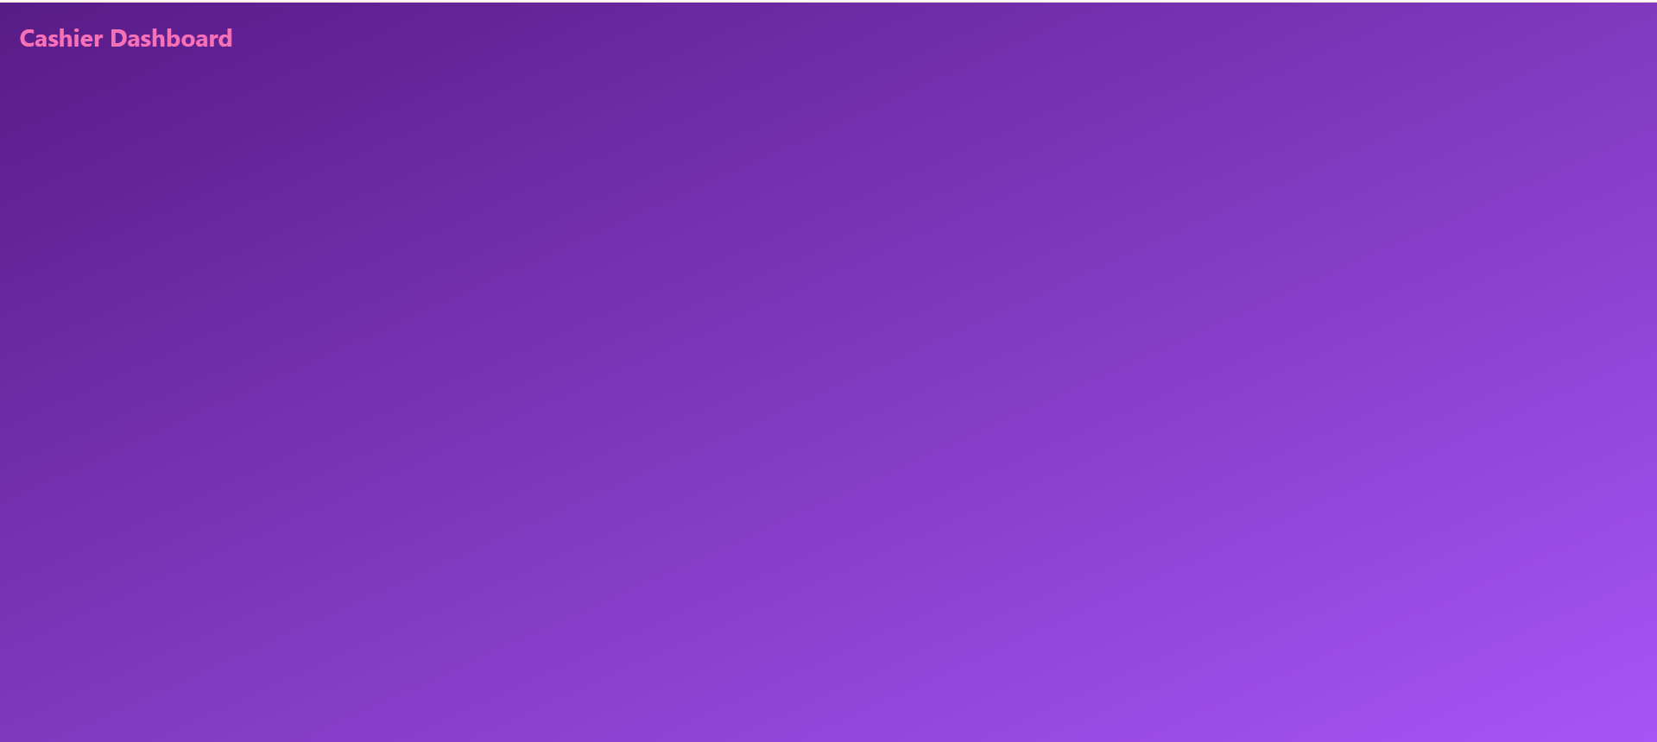

**SOME TWEAKS :**

import React from 'react';

function App() {

  return (

    <>

    <div className="min-h-screen bg-gradient-to-br from-purple-900 to-purple-500 text-white p-6">

      <h1 className="text-3xl font-bold text-pink-400">Cashier Dashboard</h1>

      <div>This is div #1</div>

    </div>

    <div className='text-gray-800'>This is div #2</div>

    </>

  );

}

export default App;

**OUTPUT :**

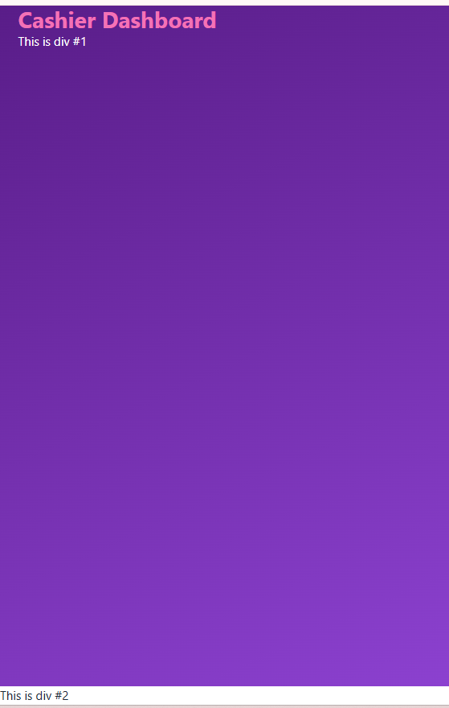

**STEP # 2 :**

**🛒 Step: Add Cart Icon to Top Right**

We'll do this:

1. Create a **header row** with two parts:
   * Left: "Cashier Dashboard"
   * Right: 🛒 Cart icon

**🛠 Updated App.jsx Top Section**

Replace old code:

With this:

<div className="flex justify-between items-center">

<h1 className="text-3xl font-bold text-pink-400">Cashier Dashboard</h1>

<span className="text-2xl cursor-pointer">🛒</span>

</div>

**💡 Explanation:**

* flex justify-between → Puts the title on the left and the icon on the right
* items-center → Vertically centers both
* text-2xl → Makes the cart icon bigger
* cursor-pointer → Changes cursor on hover like a button

**🟨 Why Did We Use <span> for the Cart Icon?**

**✅ 1. Because <span> is inline by default**

That means:

* It **doesn’t break the line**
* It **sits neatly** next to other elements (like inside a button or header)

Perfect for **small content**, like:

* Emojis (🛒)
* Single icons
* Bits of styled text (like "text-bold" inside a paragraph)

**💡 In our case:**

jsx

CopyEdit

<span className="text-2xl cursor-pointer">🛒</span>

This:

* Makes the 🛒 **sit nicely** in the top-right of the page
* Doesn’t break layout
* Allows us to size and style it with Tailwind (text-2xl, cursor-pointer)

**❓Could We Use a <div> or <p>?**

Technically yes, but they are **block elements**, so:

* They’d take the whole width
* Might mess up alignment
* Not ideal for a tiny icon

**🎯 When to use <span>:**

Use it when you need:

* Small inline content
* Custom styling on part of a sentence
* A symbol or emoji like 🛒, 🔍, or ✏️ inside a button or corner

**🧠 Here's the truth:**

💡 **Tailwind overrides the default HTML behavior.**

That means: Even though <div> is normally a block element (goes full width), your Tailwind class made it behave like an inline one.

**You had this:**

jsx

CopyEdit

<div className="flex justify-between items-center">

<h1 className="text-3xl font-bold text-pink-400">Cashier Dashboard</h1>

<div className="text-2xl cursor-pointer">🛒</div> ← changed from span

</div>

**So why did it look fine?**

Because Tailwind added:

* text-2xl: Controls size
* cursor-pointer: Styling
* And most importantly:  
  You placed it **inside a flex container** (justify-between items-center), so the div was forced to behave like a small block in a row.

**✅ Key Rule:**

Inside a flex, even a <div> can act like an inline box  
That’s why the layout didn’t break.

**📌 So when do we *prefer* <span>?**

When we:

* Want to use it inside a line of text
* Know it’s just a tiny item
* Want better semantics or smaller HTML

But visually, in Tailwind layouts — it often doesn’t matter as much, because you control everything with classes.

**TWEAKED CODE :**

<div className="min-h-screen bg-gradient-to-br from-purple-900 to-purple-500 flex justify-between items-center">

  <h1 className="text-3xl font-bold text-pink-400">Cashier Dashboard</h1>

  <span className="text-2xl cursor-pointer">🛒</span>

  </div>

**OUTPUT :**

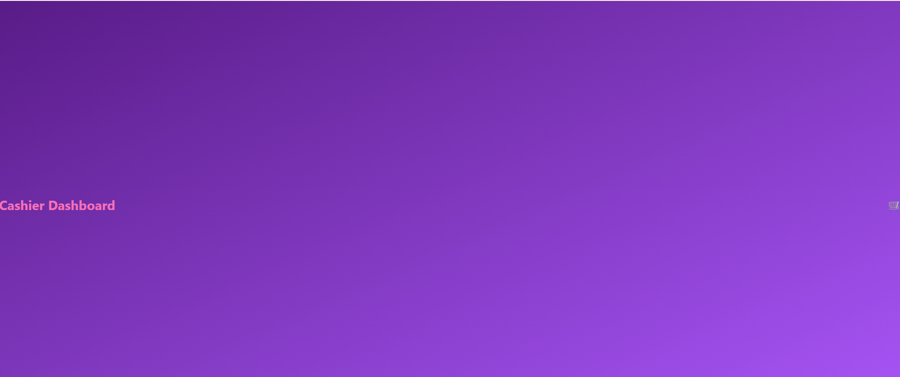

**🧠 The Problem:**

You used:

jsx

CopyEdit

<div className="min-h-screen bg-gradient-to-br from-purple-900 to-purple-500 flex justify-between items-center">

So Tailwind is saying:

* Make the div **as tall as the screen** (min-h-screen)
* Use flex to spread two items **vertically centered**
* Since there’s only one div, that **entire full screen** is being used just for the header

😅 That’s why "Cashier Dashboard" is hugging the bottom left, and the 🛒 is hugging the bottom right.

**✅ The Fix: Separate the header from the screen wrapper**

We’ll do it like this:

jsx

CopyEdit

import React from 'react';

function App() {

return (

<div className="min-h-screen bg-gradient-to-br from-purple-900 to-purple-500 text-white p-6">

{/* Header row */}

<div className="flex justify-between items-center mb-8">

<h1 className="text-3xl font-bold text-pink-400">Cashier Dashboard</h1>

<span className="text-2xl cursor-pointer">🛒</span>

</div>

{/* More content will come here */}

</div>

);

}

export default App;

**🔍 What changed:**

* min-h-screen, bg-gradient, p-6 — now wrap the **whole page**
* flex justify-between items-center — now applies **only to the header row**
* mb-8 — adds margin-bottom below the header so the next section has room

**✅ Now you’ll see:**

* **Heading on the top-left**
* **Cart on the top-right**
* **Nice padding**
* **Room below to add the next section**

**🧱 mb-8 — What is it?**

**mb means:**

**margin-bottom** → space added **below the element**

**mb-8 means:**

Add 8 units of bottom margin (about 2rem or 32px) under this div

So visually, it pushes the next thing (like your form) **down by 32px** from this header row.

**📏 How much space does this div take?**

You're referring to this:

jsx

CopyEdit

<div className="flex justify-between items-center mb-8">

<h1>...</h1>

<span>🛒</span>

</div>

**That div will take:**

* Only as much **height as its content needs**
* The two items (heading + 🛒 icon) will be in a **row**
* Because of items-center, they’ll be vertically aligned in the middle (if they were taller)
* Because of justify-between, they’ll sit **on opposite ends** of the row

So overall, the **height of this div is just enough to fit the heading + icon**, and it won’t stretch unless we force it.

**OUTPUT :**

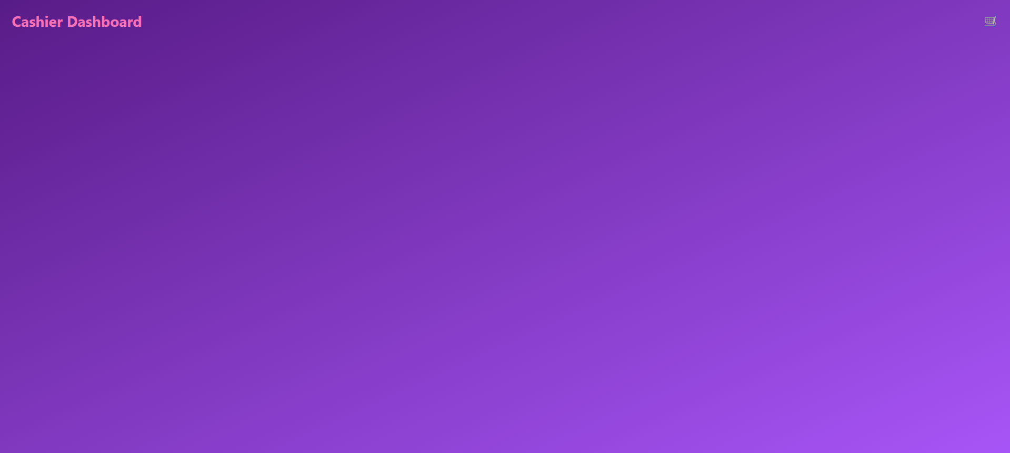

**STEP 3 : ( Add new item )**

import React from 'react';

function App() {

  return (

    <div className="min-h-screen bg-gradient-to-br from-purple-900 to-purple-500 text-white p-6">

      {/* Header row */}

      <div className="bg-blue-200 flex justify-between items-center mb-8">

        <h1 className="text-3xl font-bold text-pink-400">Cashier Dashboard</h1>

        <span className="text-2xl cursor-pointer">🛒</span>

      </div>

      {/* Add New Item Section */}

<div className="bg-purple-800 p-6 rounded-lg mt-6">

  <h2 className="text-xl font-semibold text-white mb-4 flex items-center gap-2">

    <span>➕</span> Add New Item

  </h2>

  <div className="flex flex-wrap gap-4">

    <input

      type="text"

      placeholder="Item Name"

      className="bg-white/10 text-white px-4 py-2 rounded placeholder-white/70 w-40"

    />

    <input

      type="text"

      placeholder="Price"

      className="bg-white/10 text-white px-4 py-2 rounded placeholder-white/70 w-40"

    />

    <input

      type="text"

      placeholder="Stock"

      className="bg-white/10 text-white px-4 py-2 rounded placeholder-white/70 w-40"

    />

    <button className="bg-gray-600 text-white px-4 py-2 rounded hover:bg-gray-500">

      Upload Photo

    </button>

    <select className="bg-white/10 text-white px-4 py-2 rounded w-44">

      <option>Select Category</option>

    </select>

    <button className="bg-green-600 text-white px-4 py-2 rounded hover:bg-green-700">

      ➕ Add Item

    </button>

  </div>

    </div>

    </div>

  );

}

export default App;

**🔍 EXPLANATION PART BY PART**

**🟪 1. The Outer Purple Box:**

jsx

CopyEdit

<div className="bg-purple-800 p-6 rounded-lg mt-6">

| **Class** | **What it does** |
| --- | --- |
| bg-purple-800 | Makes the box dark purple |
| p-6 | Adds padding inside the box (space around content) |
| rounded-lg | Gives smooth rounded corners |
| mt-6 | Adds space above the box (margin-top) so it doesn’t touch the header |

📦 This is your **form container** — it holds everything inside it.

**🟣 2. Heading:**

jsx

CopyEdit

<h2 className="text-xl font-semibold text-white mb-4 flex items-center gap-2">

<span>➕</span> Add New Item

</h2>

| **Class** | **What it does** |
| --- | --- |
| text-xl | Makes the text bigger |
| font-semibold | Makes the text bold-ish |
| text-white | Makes the text white |
| mb-4 | Adds space below the heading |
| flex items-center | Puts the icon and text on the same line, vertically centered |
| gap-2 | Adds space between icon and text |

So you get:

➕ Add New Item

**🔲 3. The Inputs Row:**

jsx

CopyEdit

<div className="flex flex-wrap gap-4">

| **Class** | **What it does** |
| --- | --- |
| flex | Puts all elements in a row |
| flex-wrap | Allows wrapping to a new line on small screens |
| gap-4 | Adds spacing between all inputs/buttons |

This wraps all your input fields and buttons **into a responsive row**.

**🧾 4. The Input Fields:**

Example:

jsx

CopyEdit

<input

type="text"

placeholder="Item Name"

className="bg-white/10 text-white px-4 py-2 rounded placeholder-white/70 w-40"

/>

| **Attribute / Class** | **Meaning** |
| --- | --- |
| type="text" | It’s a text input |
| placeholder="Item Name" | Shows grey text inside the box until user types |
| bg-white/10 | Light transparent background |
| text-white | Makes typed text white |
| px-4 | Horizontal padding inside |
| py-2 | Vertical padding inside |
| rounded | Soft corner edges |
| placeholder-white/70 | Makes placeholder white-ish (70% opacity) |
| w-40 | Fixed width (about 10rem) |

Same styles apply to "Price" and "Stock".

**🧰 5. Upload Photo Button**

jsx

CopyEdit

<button className="bg-gray-600 text-white px-4 py-2 rounded hover:bg-gray-500">

Upload Photo

</button>

| **Class** | **Meaning** |
| --- | --- |
| bg-gray-600 | Grey background |
| text-white | White text |
| px-4 py-2 | Padding inside button |
| rounded | Rounded corners |
| hover:bg-gray-500 | Lightens on hover |

**🧾 6. Category Dropdown**

jsx

CopyEdit

<select className="bg-white/10 text-white px-4 py-2 rounded w-44">

<option>Select Category</option>

</select>

Same logic as inputs:

* select is a dropdown
* Same styling (rounded, white text)
* w-44 gives a slightly wider width

**✅ 7. Add Item Button**

jsx

CopyEdit

<button className="bg-green-600 text-white px-4 py-2 rounded hover:bg-green-700">

➕ Add Item

</button>

* Green background
* White text
* Rounded corners
* Hover makes it slightly darker green

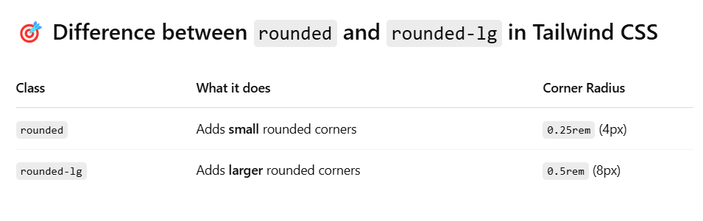

**NOTE :**

### 🔹 mx-auto → Horizontal Centering of Blocks

**mx-auto** = margin-left: auto + margin-right: auto

👉 It’s used to **center an entire box**, like a <div> or a <section>  
✅ Only works if the element has a **width** (like w-full, max-w-3xl, etc.)

#### 📦 Example:

html

CopyEdit

<div class="w-1/2 mx-auto bg-yellow-100">I’m centered block-wise</div>

| **Without mx-auto** | **With mx-auto** |
| --- | --- |
| Sits left-aligned | Gets centered in page |

### 🔹 text-center → Centering Text Inside

**text-center** = centers the **text inside an element**

👉 It works on inline content like:

* Headings (<h1>, <h2>)
* Paragraphs (<p>)
* Spans, inline elements

#### 📝 Example:

html

CopyEdit

<div class="text-center">

<p>This paragraph is centered inside the box</p>

</div>

| **Without text-center** | **With text-center** |
| --- | --- |
| Text hugs left | Text sits in the center of the box |

### ✅ Most Powerful Combo

html

CopyEdit

<div class="max-w-2xl mx-auto text-center">

<h1 class="text-3xl font-bold">Hello World</h1>

<p>This heading and this paragraph are both centered beautifully.</p>

</div>

* max-w-2xl limits the content width (so it's not stretched)
* mx-auto centers the **whole block**
* text-center centers the **text inside**

### 🧠 Summary:

| **Class** | **Centers What?** | **Example Use** |
| --- | --- | --- |
| mx-auto | Whole box / container | div, section, form |
| text-center | Just the text inside | h1, p, span, buttons |

**[NOTE ENDED]**